SUBJECT:  APPLICATIONS DEVELOPMENT THEORY IV  (APT470S)  Full-time and Part-time | EXAM DATE:  NOVEMBER 2022 | DURATION:  2 Hours | TOTAL MARKS:  60



DEPARTMENT OF INFORMATION TECHNOLOGY
FACULTY OF INFORMATICS AND DESIGN

COURSE(S): ADICTA: ADVANCED DIPLOMA IN INFORMATION AND COMMUNICATION TECHNOLOGY: APPLICATIONS DEVELOPMENT

EXAMINER: MS G KHAN
MODERATOR: MR T MAKHURANE
EXTERNAL MODERATOR: DR M NORMAN

GENERAL INSTRUCTIONS
- This is an individual test that should solely be done by you.
- You are required to answer all questions in blue or black ink.
- All test questions relate to the scenario supplied below. Carefully study the case before answering the questions.
- This test counts 30% of your final mark for this subject and covers work from semester 2 as per the topic list and Subject Guide.

Scenario for the GoodHealth Pharmacy

Assume that you are the developer for an online pharmacy (GoodHealth Pharmacy) that caters to senior citizens. The pharmacy provides the typical functions that a physical pharmacy would, and it maintains a database for each customer so that it can provide information on medicines they take and warn of potential drug interactions. In addition, the pharmacy intends to fully automate some of their processes such as the prescribing and delivering prescription medicines. All work processes revolve around a web-based application which is accessible by doctors (or their assistants), pharmacists, and patients. The various users will implement their tasks from different interfaces with a similar look and feel.

At present, the webApp is still in development. Given the focus is on quality several tests (see below) have been earmarked for ensuring that the app meets its requirements and strategies are in place for managing the software and the project to completion.

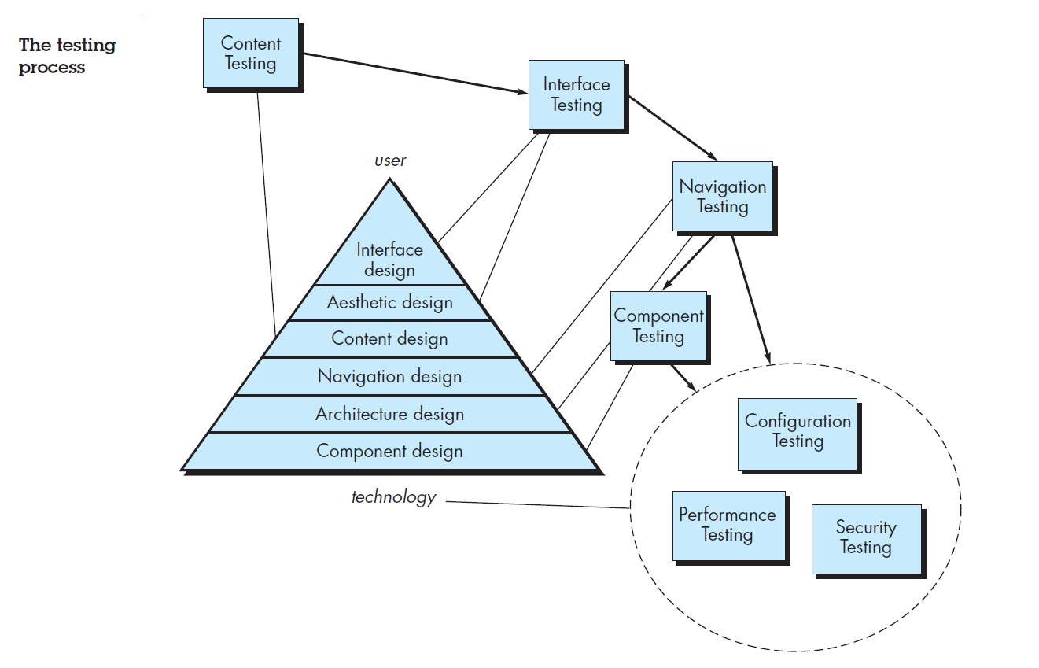

Based on this scenario answer the following questions -

